File permission Task :

Step 1: Going to cd/home and then listing the files

Screen shot mentioned below

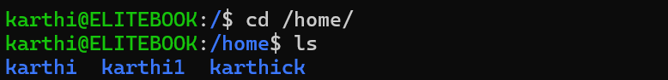

Step 2:

Using touch command creating demo.txt into home directory but its showing permission denied because we cannot creating the file directly in the Home for that we need to give permission to the user

Screenshot mentioned below:



Step 3:

So for that I used the sudo command{sudo touch /home/demo.txt} for create the .txt file in home directory but it is the root user and listing the file

Screen shot mentioned below:

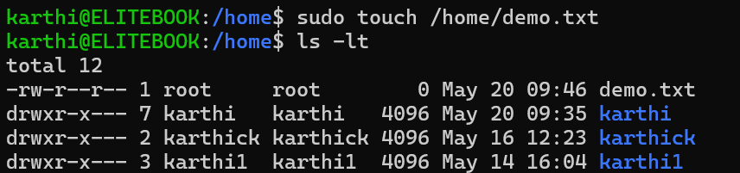

Step 4:

So for that now iam changing the owner and goup in the karthi User using command of sudo chown karthi:karthi /home/demo.txt

Screenshot mentioned below

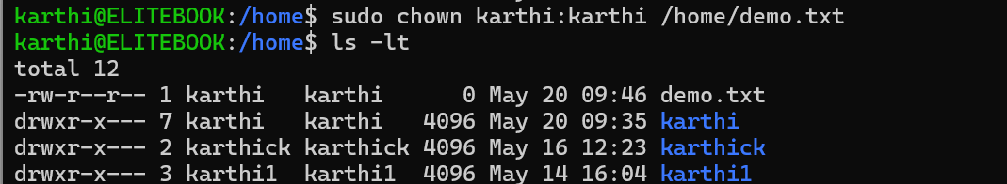

Step 5:

So now iam going to give the read wirte execute permission to the demo.txt file using sudo chmod 764 demo.txt this command

For owner ->read,write,execue 🡪 4+2+1 =7

For group ->read and write only🡪 4+2+0=6

For others users_> only read🡪 4+0+0=4

Screenshot mentioned Below:

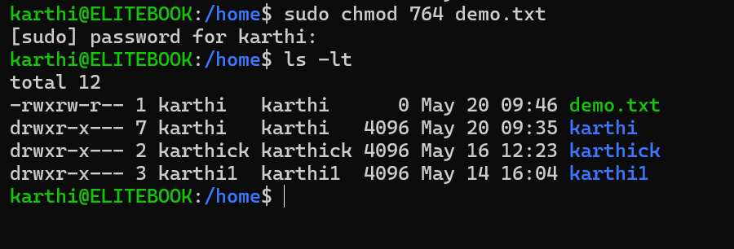

So now the Owner will have rwx and group will have rw and then other user will only hae the read permission in the file

Complete Screenshot Mentioned in Below:

